**Setup**

**Android Development Requirements**

To build apps for Android, you need to have a computer that can run Android Studio and allow you to test your app. If you have a PC, you'll need to have Windows 7, 8, 8.1, or 10 installed. That computer needs to have two GB of RAM with eight GB recommended. The computer should have two GB minimum of disk space, with four GB or more recommended to install the virtual device images, you'll use an emulator to test your apps. You need to have 1280 by 800 minimum screen resolution.

And it is recommended that you have a 64-bit operating system with some advanced capabilities to optimize the emulator experience on your PC. If you have a Mac, you'll need Mac OS verion 10.8.5 or higher installed. That computer needs to have two GB of RAM with eight GB recommended. And the computer should have two GB minimum of disk space, with four GB or more recommended for the device images. You will also need to have a 1280 by 800 minimum screen resolution. You will also need an Android developer account if you wish to publish the app to the Google Play Store.

This isn't required for the course, but you will need it after this course if you wish to list your app in the store. To get an account, you need to register with Google. A registration costs 25 dollars at the time that this course was made, and it is a one-time payment. To sign up, you need to go through the registration process at the website listed here. The process requires that you have a Google account, or that you set one up as you complete the registration. It also requires that you pay with a credit card, or Android Pay. If you want to test your app on your own physical hardware, like a phone or tablet, you need to put the device into Developer Mode.

The method to do this varies based on the device, so check online to find the right method for your specific hardware.

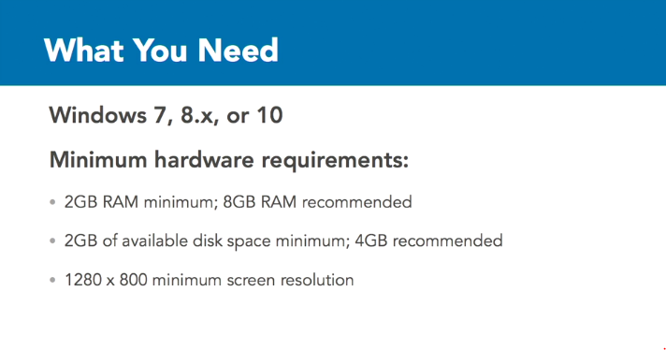

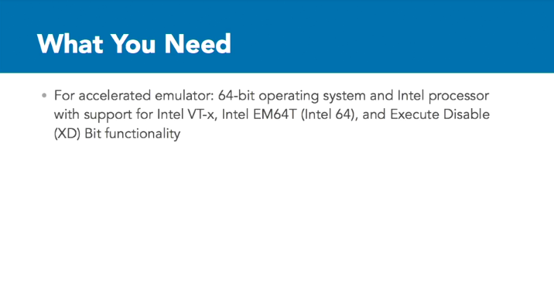

Mac:

